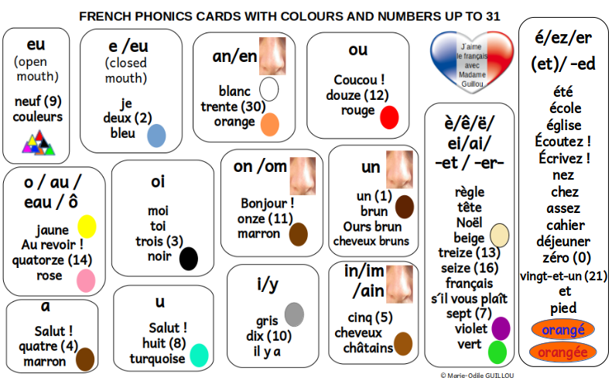
https://www.youtube.com/watch?v=VDND1vGQ9Ew
https://www.youtube.com/watch?v=VDND1vGQ9Ew

